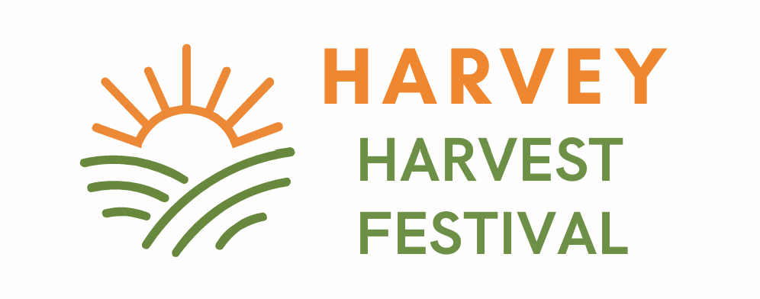

We invite you to join us as stallholder for the Harvey Harvest Festival 2025.

**Stallholder Bylaws**

Please be advised that the following Bylaws apply. Please read carefully!

**Festival Theme**

The Harvey Harvest Festival is celebrating its 26th year and is looking to be bigger than ever. As an Italian harvest themed festival, and we ask that all stallholders theme their stall. The Italian flag is red, white & green. We hope that by incorporating this theme across the whole event that it will leave a lasting impression on our visitors and add to the atmosphere.

**Applications**

Applications are open for HHF 2025.

All applications must be made online to allow us to keep administration costs and stallholder fees down.

**Allocation of Bays**

Every effort will be made to accommodate the requests of stallholders regarding preferred position. The selection criteria are based on, all documentation being received followed by first in first served basis. Stallholders will be contacted by email to confirm participation in the event.

Confirmation of bay numbers will be sent four weeks prior to the event via email. If necessary, stallholders may be offered an alternative site.

Late applications are not accepted. The festival does not have a cancellation list.

**Payment**

Full non-refundable payment for stallholder’s bay will be required with stallholder applications. Refunds will be only be provided if stallholders are unable to be accommodated.

**Online Application Only**

The Harvey Harvest Festival has an on-line booking system, and all applications must be made online. The online system allows Harvey Mainstreet to keep administration costs and stallholder fees down.

An administration fee will apply if stallholders are unable to lodge a stallholder application online. These requests must be made by emailing [Harveyharvestinfo@gmail.com](mailto:Harveyharvestinfo@gmail.com)

**Food Vans**

It is a requirement under the Food Act 2008 for all food and drink vendors to have a Certificate of Registration of a Food Business. If in doubt, please find the relevant information you need on the Shire of Harvey’s website and complete this online.

<https://www.harvey.wa.gov.au/services/public-health/food-business-safety-and-approvals>

It is also a requirement that the I’m Alert – free Food Safety course has been completed. This is also found through the above link.

Stallholders must provide a copy of these certificates when registering for a stall.

Stallholders will not be admitted to the festival unless these certificates have been supplied by 1 February 2025.

All vendors must also liaise with the Shire for a Temporary Food Stall Permit and can do this by using the following Shire link:

[application-for-temporary-food-stall-permit-2023](https://www.harvey.wa.gov.au/documents-and-forms/others/2023/november/application-for-temporary-food-stall-permit-2023)

**Public Liability**

All stallholders must supply a copy of their current Public Liability Insurance when registering for a stall.

Stallholders who don't hold public liability insurance should inquire with an insurance broker about coverage for the duration of the festival.

Stallholders will not be admitted to the festival unless a copy of their current Public Liability Insurance has been supplied by 1 February 2025.

**Stall Bay Sizes**

Please ensure stallholders stall fits into the allocated bay size. If stallholders have a trailer, stallholders must include tow bar into stallholder’s bay size. If you have concerns about your stall size please contact the coordinator.

**Bay Sizes - See website**

Snell Park: (In the park, on grass)

Hayward St:(On the adjoining road, on bitumen)

Piazza: NO POWER (Italian food/goods stalls only)

Snell Park North: (Rides/amusements/ food)

Please ensure stallholders are in the correct bay as festival staff will assist stallholders to move stallholders bay, regardless of whether stallholders have set up or not.

Stallholders who arrive on the day with stalls larger than they have booked will be relocated, space permitting.

If there is no space, they will be turned away.

Booking fees are non-refundable.

**Access**

All access is via the entrance on Hayward Street.

Stallholders in Snell Park North may access the grounds by the northern end of Hayward Street.

Strictly no vehicles in the festival area after 8:30am.

The road will be closed.

**Set Up**

Snell Park will be set up in stages from 6.00am to prevent congestion.

Stallholders will be allocated a time slot for arrival to set up and the entrance to access stallholders bay when stallholders receive stallholders bay number confirmation slip. Please do not set up earlier or later than stallholders designated time - stallholders may be asked to pack up if blocking access ways.

Stallholders who miss their time will be allocated an alternative bay outside Snell Park, either in Snell Park North or on Hayward Street, space permitting. Stands must be completely set up and fully functional by 9am on festival day.

**Pack Down**

Stallholders are asked not to start packing down before 4pm. Moving equipment and goods and loading cars before this time is a safety hazard, and as part of the Festival’s Safety Hazard Analysis approved by the Shire of Harvey, stallholders will be asked to cease immediately. Failure to do this will result in no further invitations to the event.

**How to find your bay:**

A festival map is provided to stallholders prior to the event with bay confirmation and volunteers stationed at festival entrances will direct stallholders to their bay. Please bring stallholders bay number confirmation on festival day as this will save time.

**Parking:**

Parking is available in Snell Park North & the surrounding township of Harvey. Please do not park stallholder’s vehicle alongside stallholder’s stall, as this is a safety hazard and in contravention of the Festival’s Safety Hazard Analysis, approved by the Shire of Harvey. Stallholders will be asked to remove stallholder’s vehicle immediately.

**How to get to Harvey Harvest Festival at Snell Park / Hayward St:**

[Hayward St - Google Maps](https://www.google.com/maps/place/Hayward+St,+Harvey+WA+6220/@-33.0778104,115.8972424,17z/data=!3m1!4b1!4m6!3m5!1s0x2a321d78511f7b35:0xa3461c1bd948beb2!8m2!3d-33.0778104!4d115.8972424!16s%2Fg%2F11cjg6_v69?entry=ttu&g_ep=EgoyMDI0MTEwNi4wIKXMDSoASAFQAw%3D%3D)

**Security and first aid**

Security is the responsibility of the stallholder. Please be aware of products left unattended on stallholders stand.

Security will be in place between 9am – 4pm and based at the wine area of the festival.

First Aid tent – refer to map

**Power**

AMPs and the number required must be stated on the application form.

Stallholders will not be provided with extra outlets on the day.

Positions with electricity are extremely limited. Piazza and Hayward South are unpowered.

Stallholders granted a powered bay are to provide their own serviceable extension cord with **safety tag** attached by authorised electrician.

Please use gas if possible.

No power boards.

If we are unable to accommodate stallholders’ request for power, we will contact stallholders ASAP.

**Equipment**

Trestles, tables, marquees, extension cords, cooking equipment, fridges or glasses etc are not supplied and only limited shade is available. Please make stallholders own arrangements and ensure items are secure/ safe.

**Beer/ Wine/ Gin Tasting**

All stallholders promoting alcohol will be positioned together in the official Wine Tasting Area located in Snell Park. This area is powered and will be covered by a single Occasional Licence obtained by Harvey Mainstreet Committee Inc.

Wine and tasting experience will be incorporated into the event. Takeaway goods may be purchased but not opened at this event.

**Other**

Stallholders are requested to leave their site clean and tidy.

Stallholders participate in the Harvey Harvest Festival at their own risk.

**CHECKLIST**

Stallholders, please ensure you have completed the following:

* Online stallholder application
* Payment in full through website
* Certificate of Currency / Public Liability Insurance has been uploaded online or emailed to [clo-clo1983@hotmail.com](mailto:clo-clo1983@hotmail.com) or posted to PO Box 265 Harvey, WA, 6220

Food and drink vendors must also complete:

* Application for Sale of food – Temporary Vendor – online (Shire of Harvey)
* I’m alert Food Safety Course Certificate provided (shire of Harvey)
* Certificate of Registration of a Food Business - has been uploaded online or emailed to [clo-clo1983@hotmail.com](mailto:clo-clo1983@hotmail.com) or posted to PO Box 265 Harvey, WA, 6220

**CONTACT:**

The Festival Co-ordinator Chloe Palmer can be contacted at 0407 966 175

Stallholder enquiries query will be attended to as soon as possible.